SIMATS ENGINEERING ASSESSMENT TOOL 1

COURSE NAME: MLA03
COURSE CODE: Reinforcement learning

COURSE OUTCOME COVERED
CO1: Analyze reinforcement learning frameworks and Markov Decision Process concepts to model decision-making problems. (BL2, BL3)
Assessment Tool Weightage: 50%

Dr. G. A. Senthil

QUESTIONS: 10 Total Marks: 50

Annexure A

RL Basic Experiments demo with Keras and TensorFlow using Anaconda navigator

Duration: 2hrs

Code of Conduct:

I K.B.S Pradeep / 192325112 (Name / Reg No) certify that this submission is my original work and that I have adhered to the guidelines specified for this assessment.
I understand that any violation of academic integrity rules will result in disciplinary action.

Signature of the student: K.B.S Pradeep

EXP 01:
import sys
import platform
import importlib

modules = {
"NumPy": "numpy",
"Matplotlib": "matplotlib",
"Gymnasium": "gymnasium",
"TensorFlow": "tensorflow",
"Keras": "keras"
}

print("Python Version :", platform.python_version())
print("Operating System :", platform.system(), platform.release())
print("Python Path :", sys.executable)

missing = []

for name, module in modules.items():
spec = importlib.util.find_spec(module)

if spec is not None:
lib = importlib.import_module(module)
version = getattr(lib, "__version__", "Unknown")
print(f"{name} -> Installed (Version: {version})")
else:
print(f"{name} -> Not Installed")
missing.append(name)

if not missing:
print("\nAll required libraries are available.")

import gymnasium as gym

env = gym.make("CartPole-v1")
observation, info = env.reset(seed=42)

total_reward = 0

while True:
action = env.action_space.sample()
observation, reward, terminated, truncated, info = env.step(action)

total_reward += reward

if terminated or truncated:
break

env.close()

print(f"CartPole test completed with reward: {total_reward}")
print("Reinforcement Learning environment is working correctly.")
else:
print("\nMissing libraries:", ", ".join(missing))

Output:

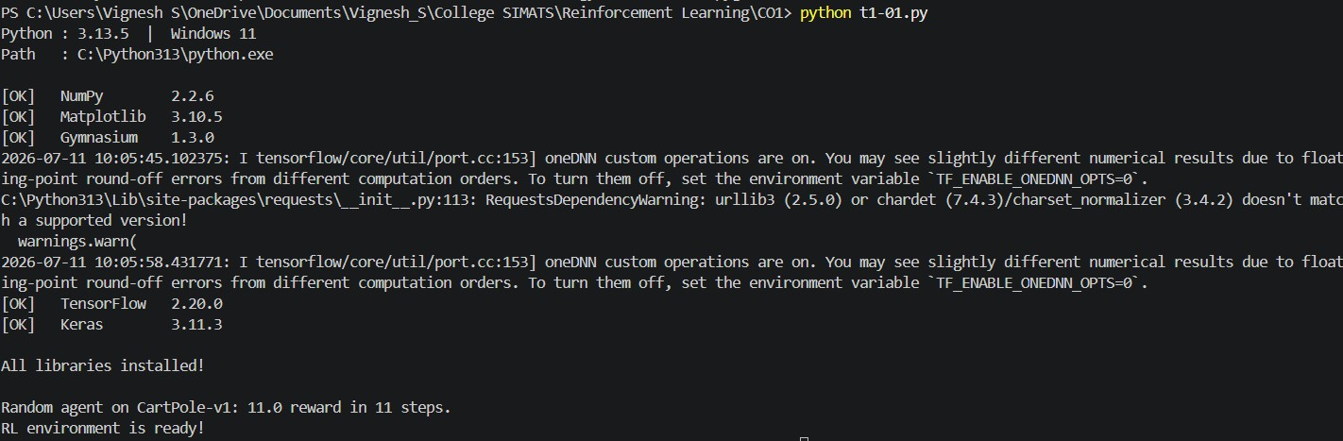

EXP 02:

import gymnasium as gym

environments = [

("FrozenLake-v1", {"is_slippery": False}),

("CartPole-v1", {}),

("MountainCar-v0", {})

]

for env_name, params in environments:

print(f"\n--- {env_name} ---")

env = gym.make(env_name, **params)

print("Observation Space:", env.observation_space)

print("Action Space:", env.action_space)

state, _ = env.reset(seed=42)

total_reward = 0

for step in range(10):

action = env.action_space.sample()

state, reward, terminated, truncated, _ = env.step(action)

total_reward += reward

print(

f"Step {step+1}: Action={action}, Reward={reward}, Done={terminated or truncated}"

)

if terminated or truncated:

break

print("Total Reward:", total_reward)

env.close()

OUTPUT:

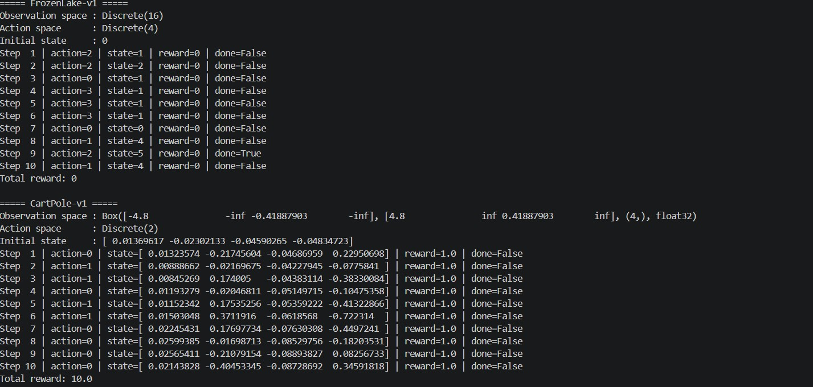

EXP 03:
import numpy as np
import gymnasium as gym

env = gym.make("FrozenLake-v1", is_slippery=False)

states = env.observation_space.n
actions = env.action_space.n

Q = np.zeros((states, actions))

learning_rate = 0.8
discount = 0.95
epsilon = 1.0

scores = []

for ep in range(2000):

state, _ = env.reset()
total_reward = 0

while True:

# Choose action
if np.random.rand() < epsilon:
action = env.action_space.sample()
else:
action = np.argmax(Q[state])

next_state, reward, terminated, truncated, _ = env.step(action)

# Q-learning update
best_next = np.max(Q[next_state])

Q[state][action] = Q[state][action] + learning_rate * (
reward + discount * best_next - Q[state][action]
)

state = next_state
total_reward += reward

if terminated or truncated:
break

scores.append(total_reward)

# Reduce exploration
epsilon *= 0.999
if epsilon < 0.01:
epsilon = 0.01

env.close()

print("Average reward (last 100 episodes):", round(np.mean(scores[-100:]), 2))

print("\nLearned Policy:")

arrows = ["<", "v", ">", "^"]

policy = np.argmax(Q, axis=1)

for i in range(0, 16, 4):
print(" ".join(arrows[a] for a in policy[i:i+4]))

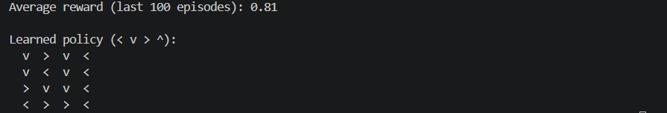
OUTPUT:

EXP 04:
import numpy as np np.random.seed(1)
# transitions[state][action] = list of (probability, next_state, reward) transitions = {
"Sleep": {"work": [(1.0, "Study", -1)], "rest": [(1.0, "Sleep", -2)]},
"Study": {"work": [(0.8, "Pass", 10), (0.2, "Play", -1)], "rest": [(1.0, "Sleep", -1)]},
"Play": {"work": [(0.6, "Study", 0), (0.4, "Play", -1)], "rest": [(1.0, "Sleep", -2)]},
}
policy = {"Sleep": "work", "Study": "work", "Play": "work"}

def step(state, action):
outcomes = transitions[state][action]
i = np.random.choice(len(outcomes), p=[o[0] for o in outcomes]) return outcomes[i][1], outcomes[i][2]

def run_episode(start="Sleep", max_steps=20):
state, total = start, 0
for _ in range(max_steps):
action = policy[state]
next_state, reward = step(state, action) total += reward
print(f" {state:<6} --({action})--> {next_state:<6} | reward = {reward}") state = next_state
if state == "Pass":
break
print(f" Total reward: {total}") return total

rewards = []
for ep in range(5):
print(f"Episode {ep + 1}:") rewards.append(run_episode())
print(f"\nAverage reward over {len(rewards)} episodes: {np.mean(rewards):.2f}")

OUTPUT:

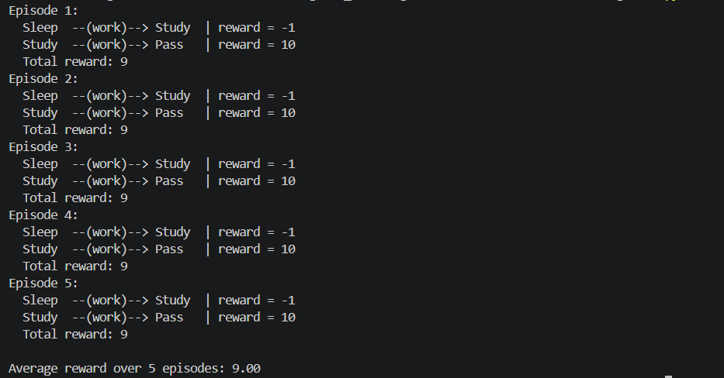

EXP 05:
import numpy as np

SIZE = 4
N = SIZE * SIZE
ACTIONS = [0, 1, 2, 3] # Up, Down, Left, Right
TERMINAL = [0, N - 1]
REWARD = -1

def move(state, action):
if state in TERMINAL:
return state
row, col = divmod(state, SIZE) if action == 0:
row = max(row - 1, 0) elif action == 1:
row = min(row + 1, SIZE - 1) elif action == 2:
col = max(col - 1, 0) elif action == 3:
col = min(col + 1, SIZE - 1) return row * SIZE + col

def policy_evaluation(gamma=1.0, theta=1e-4): V = np.zeros(N)
iterations = 0 while True:
delta = 0
for s in range(N):
if s in TERMINAL:

continue v = V[s]
V[s] = np.mean([REWARD + gamma * V[move(s, a)] for a in ACTIONS]) delta = max(delta, abs(v - V[s]))
iterations += 1 if delta < theta:
break
print(f"Policy Evaluation converged in {iterations} iterations.") return V

def value_iteration(gamma=1.0, theta=1e-4):
V = np.zeros(N) iterations = 0 while True:
delta = 0
for s in range(N):
if s in TERMINAL:
continue v = V[s]
V[s] = max(REWARD + gamma * V[move(s, a)] for a in ACTIONS) delta = max(delta, abs(v - V[s]))
iterations += 1 if delta < theta:
break
print(f"Value Iteration converged in {iterations} iterations.") return V

V_pi = policy_evaluation()
print("V(s) for random policy:")
print(np.round(V_pi.reshape(SIZE, SIZE), 2), "\n")

V_star = value_iteration() print("Optimal V*(s):")
print(np.round(V_star.reshape(SIZE, SIZE), 2), "\n")

symbols = {0: "U", 1: "D", 2: "L", 3: "R"}
print("Optimal policy:") for s in range(N):
a = int(np.argmax([REWARD + V_star[move(s, a)] for a in ACTIONS])) end = "\n" if s % SIZE == SIZE - 1 else " "
print("*" if s in TERMINAL else symbols[a], end=end)

OUTPUT:

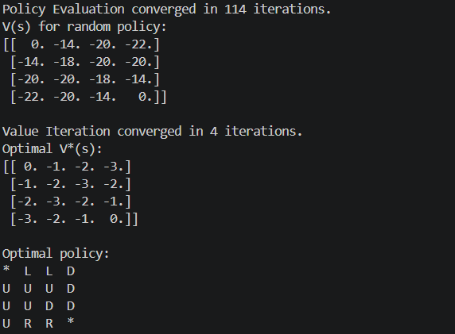

EXP 06:
import numpy as np
import matplotlib.pyplot as plt

np.random.seed(0)
K, STEPS = 10, 1000
true_values = np.random.normal(0, 1, K)

def run(strategy, epsilon=0.1):
q = np.zeros(K) counts = np.zeros(K)
rewards = np.zeros(STEPS) for t in range(STEPS):
if strategy == "random":
a = np.random.randint(K) elif strategy == "greedy":
a = int(np.argmax(q)) else: # epsilon-greedy
a = np.random.randint(K) if np.random.random() < epsilon else int(np.argmax(q)) reward = np.random.normal(true_values[a], 1)
counts[a] += 1
q[a] += (reward - q[a]) / counts[a] rewards[t] = reward
return rewards

print(f"Optimal arm: {np.argmax(true_values)}\n") plt.figure(figsize=(10, 6))
for strat in ["random", "greedy", "epsilon-greedy"]: rewards = run(strat)
print(f"{strat:<15} average reward = {np.mean(rewards):.3f}") plt.plot(np.cumsum(rewards) / (np.arange(STEPS) + 1), label=strat)

plt.xlabel("Steps")
plt.ylabel("Average Reward") plt.title("Exploration vs. Exploitation Strategies") plt.legend()
plt.grid(True, alpha=0.3) plt.tight_layout()
plt.savefig("t1-06_exploration_vs_exploitation.png", dpi=120) plt.show()

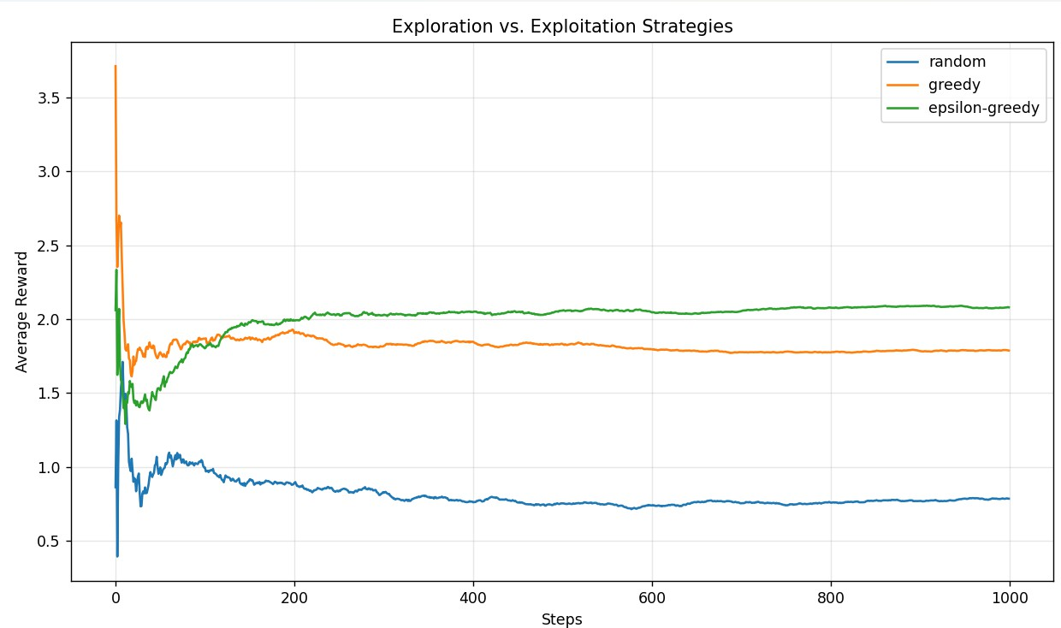
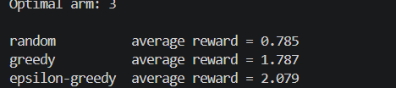
OUTPUT:

EXP 07:
import numpy as np
import matplotlib.pyplot as plt

np.random.seed(42)
K, STEPS = 10, 1000
true_values = np.random.normal(0, 1, K)

def epsilon_greedy(epsilon=0.1):
q, counts, rewards = np.zeros(K), np.zeros(K), np.zeros(STEPS) for t in range(STEPS):
a = np.random.randint(K) if np.random.random() < epsilon else int(np.argmax(q)) reward = np.random.normal(true_values[a], 1)
counts[a] += 1
q[a] += (reward - q[a]) / counts[a] rewards[t] = reward
return rewards

def ucb(c=2.0):
q, counts, rewards = np.zeros(K), np.zeros(K), np.zeros(STEPS) for t in range(STEPS):
if t < K:
a = t else:
a = int(np.argmax(q + c * np.sqrt(np.log(t + 1) / (counts + 1e-9)))) reward = np.random.normal(true_values[a], 1)
counts[a] += 1
q[a] += (reward - q[a]) / counts[a] rewards[t] = reward
return rewards

print(f"Optimal arm: {np.argmax(true_values)}\n") eg, u = epsilon_greedy(), ucb()
print(f"Epsilon-Greedy | avg = {np.mean(eg):.3f} | total = {np.sum(eg):.1f}") print(f"UCB | avg = {np.mean(u):.3f} | total = {np.sum(u):.1f}")

plt.figure(figsize=(10, 6))
plt.plot(np.cumsum(eg), label="Epsilon-Greedy (eps=0.1)") plt.plot(np.cumsum(u), label="UCB (c=2.0)")
plt.xlabel("Steps")
plt.ylabel("Cumulative Reward")
plt.title("Multi-Armed Bandit: Epsilon-Greedy vs. UCB") plt.legend()
plt.grid(True, alpha=0.3) plt.tight_layout()
plt.savefig("t1-07_bandit_comparison.png", dpi=120) plt.show()

OUTPUT:
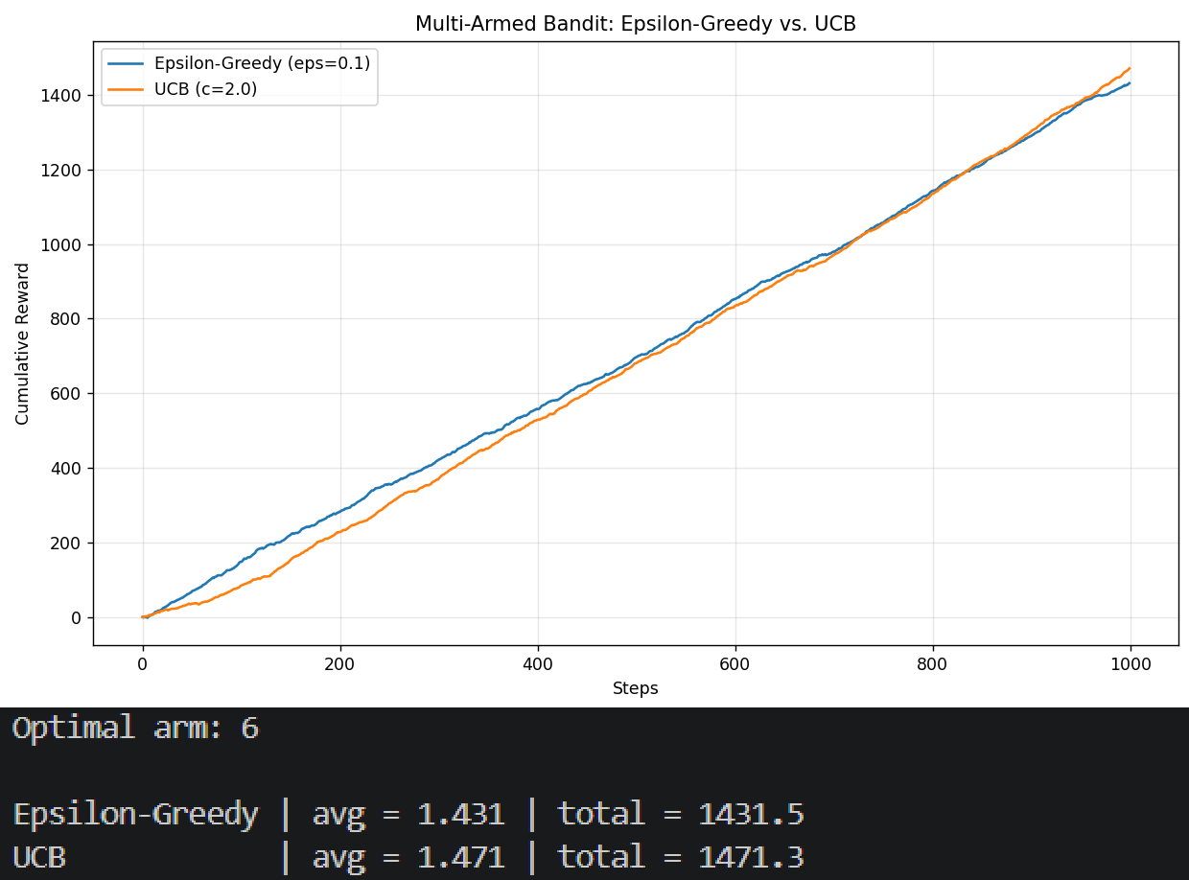

EXP 08:
import numpy as np
import matplotlib.pyplot as plt import gymnasium as gym

np.random.seed(0)
env = gym.make("FrozenLake-v1", is_slippery=True)
q = np.zeros((env.observation_space.n, env.action_space.n)) alpha, gamma, epsilon = 0.8, 0.95, 1.0
rewards = []

for episode in range(2000):
state, info = env.reset() done, total = False, 0 while not done:
action = env.action_space.sample() if np.random.random() < epsilon else int(np.argmax(q[state]))
next_state, reward, terminated, truncated, info = env.step(action) done = terminated or truncated
q[state, action] += alpha * (reward + gamma * np.max(q[next_state]) - q[state, action])
state = next_state

total += reward rewards.append(total)
epsilon = max(0.01, epsilon * 0.999)

env.close()
print(f"Average reward (last 100): {np.mean(rewards[-100:]):.3f}")

smoothed = np.convolve(rewards, np.ones(50) / 50, mode="valid") fig, axes = plt.subplots(1, 3, figsize=(16, 5))
axes[0].plot(rewards, color="tab:blue", alpha=0.6)
axes[0].set(title="Reward per Episode", xlabel="Episode", ylabel="Reward") axes[1].plot(np.cumsum(rewards), color="tab:green")
axes[1].set(title="Cumulative Reward", xlabel="Episode", ylabel="Cumulative Reward") axes[2].plot(smoothed, color="tab:red")
axes[2].set(title="Learning Curve (50-ep avg)", xlabel="Episode", ylabel="Average Reward")
for ax in axes:
ax.grid(True, alpha=0.3) plt.tight_layout()
plt.savefig("t1-08_reward_visualization.png", dpi=120) plt.show()

OUTPUT:

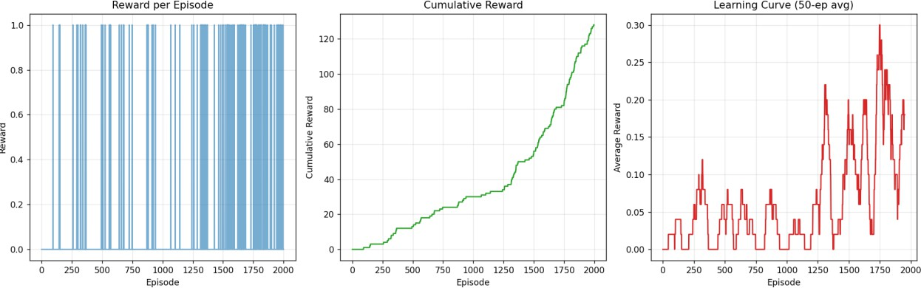

EXP 0G:
import numpy as np import gymnasium as gym
from tensorflow import keras
from tensorflow.keras import layers env = gym.make("CartPole-v1")

state_size = env.observation_space.shape[0] action_size = env.action_space.n

model = keras.Sequential([
keras.Input(shape=(state_size,)), layers.Dense(24, activation="relu"), layers.Dense(24, activation="relu"),
layers.Dense(action_size, activation="linear"),
])
model.compile(optimizer=keras.optimizers.Adam(0.001), loss="mse") model.summary()

state, info = env.reset(seed=0)
action = env.action_space.sample()
next_state, reward, terminated, truncated, info = env.step(action) state = state.reshape(1, -1)
next_state = next_state.reshape(1, -1)

q_values = model.predict(state, verbose=0)
print("\nInitial Q-values:", np.round(q_values, 4))

gamma = 0.95
target = q_values.copy()
target[0][action] = reward + gamma * np.max(model.predict(next_state, verbose=0))

loss = model.fit(state, target, epochs=1, verbose=0).history["loss"][0] print(f"Loss after one step: {loss:.6f}")
print("Updated Q-values:", np.round(model.predict(state, verbose=0), 4)) env.close()

OUTPUT:
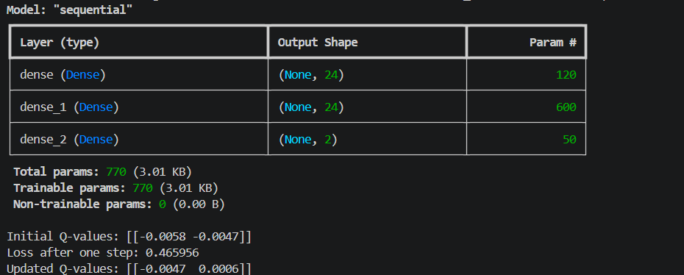

EXP 10:
import random
from collections import deque

import numpy as np
import matplotlib.pyplot as plt import gymnasium as gym import tensorflow as tf
from tensorflow import keras
from tensorflow.keras import layers

np.random.seed(0) random.seed(0)
tf.random.set_seed(0)

class DQNAgent:
def init (self, state_size, action_size): self.action_size = action_size self.memory = deque(maxlen=2000) self.gamma = 0.95
self.epsilon = 1.0
self.model = keras.Sequential([ keras.Input(shape=(state_size,)), layers.Dense(24, activation="relu"), layers.Dense(24, activation="relu"),
layers.Dense(action_size, activation="linear"),
])
self.model.compile(optimizer=keras.optimizers.Adam(0.001), loss="mse")

def act(self, state):
if np.random.rand() <= self.epsilon:
return random.randrange(self.action_size)
return int(np.argmax(self.model.predict(state, verbose=0)[0]))

def replay(self, batch_size=32):
if len(self.memory) < batch_size:
return
batch = random.sample(self.memory, batch_size) states = np.vstack([b[0] for b in batch])
next_states = np.vstack([b[3] for b in batch]) q = self.model.predict(states, verbose=0)
q_next = self.model.predict(next_states, verbose=0) for i, (_, action, reward, _, done) in enumerate(batch):
q[i][action] = reward if done else reward + self.gamma * np.max(q_next[i]) self.model.fit(states, q, epochs=1, verbose=0)
self.epsilon = max(0.01, self.epsilon * 0.995)

env = gym.make("CartPole-v1")
state_size = env.observation_space.shape[0] agent = DQNAgent(state_size, env.action_space.n) scores = []

for episode in range(100):
state, info = env.reset() state = state.reshape(1, -1) done, total = False, 0
while not done:
action = agent.act(state)
next_state, reward, terminated, truncated, info = env.step(action) done = terminated or truncated
next_state = next_state.reshape(1, -1)
agent.memory.append((state, action, reward, next_state, done)) state = next_state
total += reward agent.replay() scores.append(total)
avg = np.mean(scores[-20:])
print(f"Episode {episode + 1:>3} | reward = {total:>5.0f} | avg(20) = {avg:6.1f} | eps =
{agent.epsilon:.3f}")
if avg >= 195 and len(scores) >= 20:
print(f"\nSolved! Average {avg:.1f} >= 195") break

env.close()
print(f"\nBest reward: {max(scores):.0f} | Success rate (>=195):
{np.mean(np.array(scores) >= 195) * 100:.1f}%")

plt.figure(figsize=(10, 6))
plt.plot(scores, label="Episode Reward", alpha=0.7) if len(scores) >= 20:
moving = np.convolve(scores, np.ones(20) / 20, mode="valid") plt.plot(range(19, len(scores)), moving, color="red", label="20-episode avg")
plt.axhline(y=195, color="green", linestyle="--", label="Target (195)") plt.xlabel("Episode")
plt.ylabel("Total Reward")
plt.title("CartPole DQN - Learning Performance") plt.legend()
plt.grid(True, alpha=0.3) plt.tight_layout()
plt.savefig("t1-10_cartpole_dqn.png", dpi=120) plt.show()

OUTPUT:
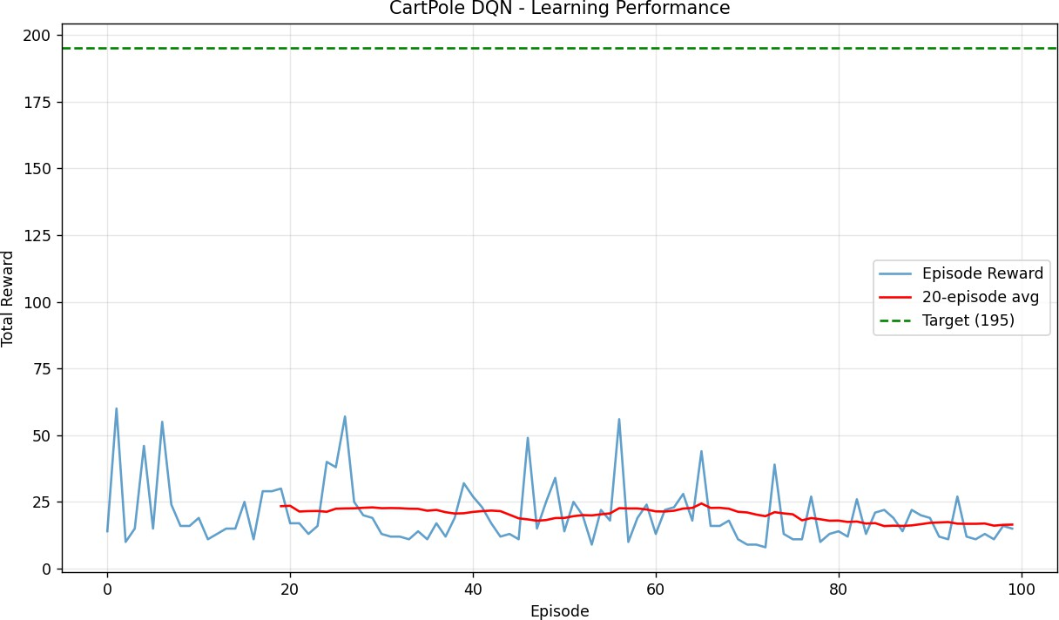
Episode 1 | reward = 14 | avg(20) = 14.0 | eps = 1.000 Episode 2 | reward = 60 | avg(20) = 37.0 | eps = 0.995 Episode 3 | reward = 10 | avg(20) = 28.0 | eps = 0.990 Episode 4 | reward = 15 | avg(20) = 24.8 | eps = 0.985 Episode 5 | reward = 46 | avg(20) = 29.0 | eps = 0.980 Episode 6 | reward = 15 | avg(20) = 26.7 | eps = 0.975 Episode 7 | reward = 55 | avg(20) = 30.7 | eps = 0.970 Episode 8 | reward = 24 | avg(20) = 29.9 | eps = 0.966 Episode 9 | reward = 16 | avg(20) = 28.3 | eps = 0.961
Episode 10 | reward = | 16 | avg(20) = | 27.1 | eps = 0.956
Episode 11 | reward = | 19 | avg(20) = | 26.4 | eps = 0.951
Episode 12 | reward = | 11 | avg(20) = | 25.1 | eps = 0.946
Episode 13 | reward = | 13 | avg(20) = | 24.2 | eps = 0.942
Episode 14 | reward = | 15 | avg(20) = | 23.5 | eps = 0.937
Episode 15 | reward = | 15 | avg(20) = | 22.9 | eps = 0.932
Episode 16 | reward = | 25 | avg(20) = | 23.1 | eps = 0.928
Episode 17 | reward = | 11 | avg(20) = | 22.4 | eps = 0.923
Episode 18 | reward = | 29 | avg(20) = | 22.7 | eps = 0.918
Episode 19 | reward = | 29 | avg(20) = | 23.1 | eps = 0.914
Episode 20 | reward = | 30 | avg(20) = | 23.4 | eps = 0.909
Episode 21 | reward = | 17 | avg(20) = | 23.6 | eps = 0.905
Episode 22 | reward = | 17 | avg(20) = | 21.4 | eps = 0.900
Episode 23 | reward = | 13 | avg(20) = | 21.6 | eps = 0.896
Episode 24 | reward = | 16 | avg(20) = | 21.6 | eps = 0.891
Episode 25 | reward = | 40 | avg(20) = | 21.3 | eps = 0.887
Episode 26 | reward = | 38 | avg(20) = | 22.4 | eps = 0.882

Episode 27 | reward = | 57 | avg(20) = | 22.6 | eps = 0.878
Episode 28 | reward = | 25 | avg(20) = | 22.6 | eps = 0.873
Episode 29 | reward = | 20 | avg(20) = | 22.8 | eps = 0.869
Episode 30 | reward = | 19 | avg(20) = | 22.9 | eps = 0.865
Episode 31 | reward = | 13 | avg(20) = | 22.6 | eps = 0.860
Episode 32 | reward = | 12 | avg(20) = | 22.7 | eps = 0.856
Episode 33 | reward = | 12 | avg(20) = | 22.6 | eps = 0.852
Episode 34 | reward = | 11 | avg(20) = | 22.4 | eps = 0.848
Episode 35 | reward = | 14 | avg(20) = | 22.4 | eps = 0.843
Episode 36 | reward = | 11 | avg(20) = | 21.7 | eps = 0.839
Episode 37 | reward = | 17 | avg(20) = | 22.0 | eps = 0.835
Episode 38 | reward = | 12 | avg(20) = | 21.1 | eps = 0.831
Episode 39 | reward = | 19 | avg(20) = | 20.6 | eps = 0.827
Episode 40 | reward = | 32 | avg(20) = | 20.8 | eps = 0.822
Episode 41 | reward = | 27 | avg(20) = | 21.2 | eps = 0.818
Episode 42 | reward = | 23 | avg(20) = | 21.6 | eps = 0.814
Episode 43 | reward = | 17 | avg(20) = | 21.8 | eps = 0.810
Episode 44 | reward = | 12 | avg(20) = | 21.6 | eps = 0.806
Episode 45 | reward = | 13 | avg(20) = | 20.2 | eps = 0.802
Episode 46 | reward = | 11 | avg(20) = | 18.9 | eps = 0.798
Episode 47 | reward = | 49 | avg(20) = | 18.4 | eps = 0.794
Episode 48 | reward = | 15 | avg(20) = | 17.9 | eps = 0.790
Episode 49 | reward = | 25 | avg(20) = | 18.2 | eps = 0.786
Episode 50 | reward = | 34 | avg(20) = | 18.9 | eps = 0.782
Episode 51 | reward = | 14 | avg(20) = | 19.0 | eps = 0.778
Episode 52 | reward = | 25 | avg(20) = | 19.6 | eps = 0.774
Episode 53 | reward = | 20 | avg(20) = | 20.1 | eps = 0.771
Episode 54 | reward = | 9 | avg(20) = | 19.9 | eps = 0.767
Episode 55 | reward = | 22 | avg(20) = | 20.4 | eps = 0.763
Episode 56 | reward = | 18 | avg(20) = | 20.7 | eps = 0.759
Episode 57 | reward = | 56 | avg(20) = | 22.6 | eps = 0.755
Episode 58 | reward = | 10 | avg(20) = | 22.6 | eps = 0.751
Episode 59 | reward = | 19 | avg(20) = | 22.6 | eps = 0.748
Episode 60 | reward = | 24 | avg(20) = | 22.1 | eps = 0.744
Episode 61 | reward = | 13 | avg(20) = | 21.4 | eps = 0.740
Episode 62 | reward = | 22 | avg(20) = | 21.4 | eps = 0.737
Episode 63 | reward = | 23 | avg(20) = | 21.7 | eps = 0.733
Episode 64 | reward = | 28 | avg(20) = | 22.5 | eps = 0.729
Episode 65 | reward = | 18 | avg(20) = | 22.8 | eps = 0.726
Episode 66 | reward = | 44 | avg(20) = | 24.4 | eps = 0.722
Episode 67 | reward = | 16 | avg(20) = | 22.8 | eps = 0.718
Episode 68 | reward = | 16 | avg(20) = | 22.8 | eps = 0.715
Episode 69 | reward = | 18 | avg(20) = | 22.4 | eps = 0.711
Episode 70 | reward = | 11 | avg(20) = | 21.3 | eps = 0.708
Episode 71 | reward = | 9 | avg(20) = | 21.1 | eps = 0.704
Episode 72 | reward = | 9 | avg(20) = | 20.2 | eps = 0.701
Episode 73 | reward = | 8 | avg(20) = | 19.6 | eps = 0.697

Episode 74 | reward = | 39 | avg(20) = | 21.1 | eps = 0.694
Episode 75 | reward = | 13 | avg(20) = | 20.7 | eps = 0.690
Episode 76 | reward = | 11 | avg(20) = | 20.4 | eps = 0.687
Episode 77 | reward = | 11 | avg(20) = | 18.1 | eps = 0.683
Episode 78 | reward = | 27 | avg(20) = | 18.9 | eps = 0.680
Episode 79 | reward = | 10 | avg(20) = | 18.5 | eps = 0.676
Episode 80 | reward = | 13 | avg(20) = | 17.9 | eps = 0.673
Episode 81 | reward = | 14 | avg(20) = | 18.0 | eps = 0.670
Episode 82 | reward = | 12 | avg(20) = | 17.5 | eps = 0.666
Episode 83 | reward = | 26 | avg(20) = | 17.6 | eps = 0.663
Episode 84 | reward = | 13 | avg(20) = | 16.9 | eps = 0.660
Episode 85 | reward = | 21 | avg(20) = | 17.1 | eps = 0.656
Episode 86 | reward = | 22 | avg(20) = | 15.9 | eps = 0.653
Episode 87 | reward = | 19 | avg(20) = | 16.1 | eps = 0.650
Episode 88 | reward = | 14 | avg(20) = | 16.0 | eps = 0.647
Episode 89 | reward = | 22 | avg(20) = | 16.2 | eps = 0.643
Episode 90 | reward = | 20 | avg(20) = | 16.6 | eps = 0.640
Episode 91 | reward = | 19 | avg(20) = | 17.1 | eps = 0.637
Episode 92 | reward = | 12 | avg(20) = | 17.3 | eps = 0.634
Episode 93 | reward = | 11 | avg(20) = | 17.4 | eps = 0.631
Episode 94 | reward = | 27 | avg(20) = | 16.9 | eps = 0.627
Episode 95 | reward = | 12 | avg(20) = | 16.8 | eps = 0.624
Episode 96 | reward = | 11 | avg(20) = | 16.8 | eps = 0.621
Episode 97 | reward = | 13 | avg(20) = | 16.9 | eps = 0.618
Episode 98 | reward = | 11 | avg(20) = | 16.1 | eps = 0.615
Episode 99 | reward = | 16 | avg(20) = | 16.4 | eps = 0.612
Episode 100 | reward = 15 | avg(20) = 16.5 | eps = 0.609 Best reward: 60 | Success rate (>=195): 0.0%

RUBRICS FOR CALCULATION

Criteria | Weightag e | Level 4 – Exemplary | Level 3 – Proficient | Level 2 – Developing | Level 1 – Beginning
Understandin g of Concepts | 25% | Demonstrate s thorough, accurate  understandin g of concepts | Good understanding with minor  gaps | Basic understanding with some  misconception s | Poor understanding; major  misconception s
Explanation | 25% | Detailed, well-  explained  answers with relevant examples | Clear explanation with adequate details | Limited explanation; lacks depth | Poor or unclear explanation
Application | 20% | Effectively applies concepts  with strong analytical ability | Applies  concepts with minor errors | Limited application with weak analysis | No application or incorrect analysis
Organization | 15% | Well-  structured  answers with logical flow and  coherence | Organized with minor issues in flow | Basic  structure, lacks clarity | Poor  organization, incoherent  answers
Accuracy | 10% | Completely accurate and covers all  required points | Mostly  accurate with minor  omissions | Partially correct with  missing points | Incorrect  answers with major gaps
Clarity | 5% | Clear, neat, professional presentation | Understandabl e with minor  issues | Limited clarity, readability  issues | Poorly written, difficult to understand

